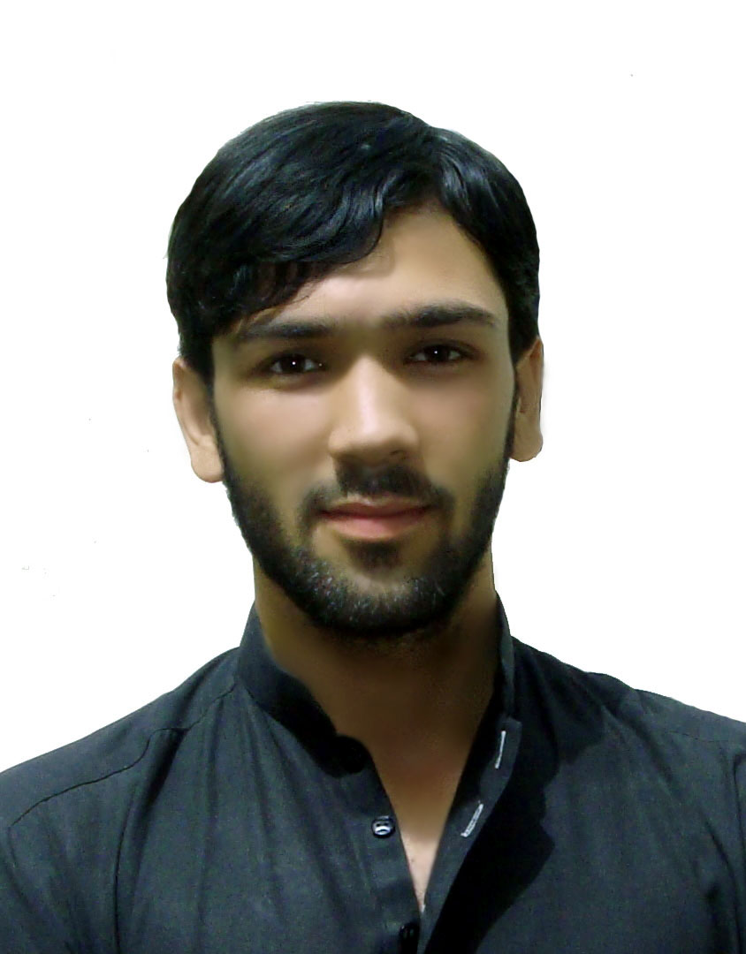

Accept and enjoy the new Situation and Challenges, make positive Contribution
Towards the given position, increase the wealth of organization enhance the knowledge, abilities and skills through
Organization by contribution

Name Jamal ud Din
Father’s Name Haji Allawa Din
Religion Islam
Nationality Afghan
Marital Status Single
Age 25 years
Address
Pakistan: Muslim Atthad colony, Mughal Abad, Eastern
Bypass road, Quetta (Baluchistan)
Mobile No +92(0)314-8122944
Email Address JAlove4all@gmail.com
JAlove4all@outlook.com

- Graduation form Bilal high school (12 years) in 2009
- Certificate of Advance level of English language From Hope English Language & computer center in 2011
- Certificate of A D I T from Clean Academy in 2011
- Certificate of Accounting in 2011from Clean Academy
- Bachelor of Computer Science(IT) from University of Baluchistan

3 Years’ Experience as a teacher in I D O / CRS (2009 till 2012)
Duties and responsibility:
- Community mobilization
- Organizing community meeting as a (SO)
- Mobilize the community of women right and gender
- Teaching street children on friendly teaching method

4 Years’ Experience as a volunteer coach in R.T.P (Right to Play Canada)
Duties and responsibility:
- Mobilize the youth member of community
- Promote sport culture among youth
- Build up youth support teams (football, volley ball, badminton and cricket)
- Conduct RTP Read ball child play Model (games for children)
- Support RTP team on organizing play days and tournament.

3 Months Experience as a mobile repairing teacher as a master trainer in (OCSD/NRC)
- Teach the students about mobile repairing
- About hard ware and software of mobile
- Showing practical diagram of mobile
- Give all information about mobile network.

2 Years’ Experience of tuition courses
Duties and responsibility:
- Developing Curriculum for classes
- Teaching student

5 Year’s Experience as a teacher in Media academy
Duties and responsibility:
- Developing Curriculum for classes
- Teaching student English language
- Maintain attendance

3 Months Experience as a Master Trainer of Mobile repairing in (TKF/NRC)
- Teach the students about mobile repairing
- About hard ware and software of mobile
- Showing practical diagram of mobile
- Give all information about mobile network.

- Days of Survey of AGRA and EGMA in (SCSPEB / CRS)
- Development about Education for Afghan Refugees and Host Community School’s Children.
- Teach about good role for Afghan Refugees school’s teachers.

Skills

- Understand writing and reading English language
- good knowledge of computer use (Microsoft office .Photoshop, accounting, use of internet , little bit IT)
- Academic knowledge of A D I T (installations, software installation, troubleshooting)
- Master trainer of Mobile repairing.
- Training method for teachers.
- Good communication in host and afghan refugee’s community
- Data analyzing in computer

TRAININGS
2 day’s Training of sport and play program R.T.P (Right to Play Canada)
2 day’s Training on peace by I.D.H.R
4 day’s Training on joy full teaching in C R S
3 day’s Training on joy full teaching in I D O
3 day’s Training on protection and education of child in Mercy corps

LANGUEGES
LANGUAGES READ WRITE SPEAK

English Good Good Good
Pashto Excellent Excellent Native
Dari very good Excellent very good
Urdu very good very good very good

REFFERENCE

Sayed Ammar Haider Agha
Program Manager CRS Protection Program Quetta
Phone # 0300-8389995
Email: Ammar.haider@crs.org

